MAASAI LEADER in snow for the FIRST TIME

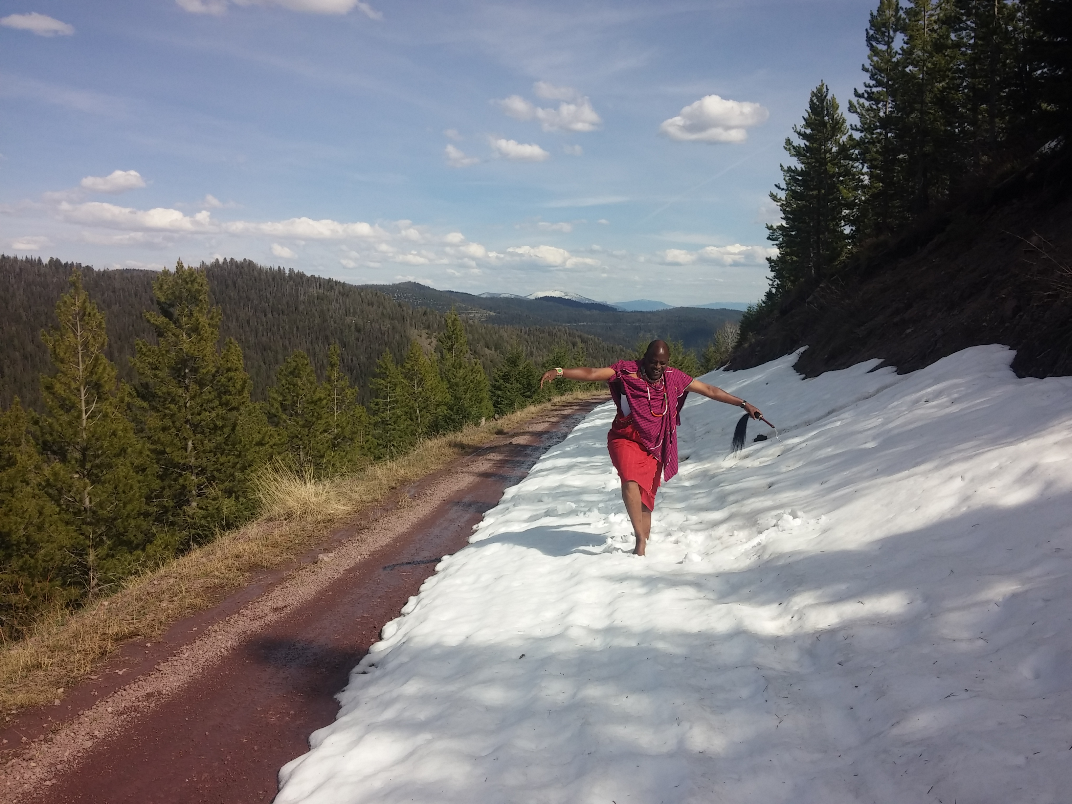

Summit in Montana as Told by Johnny Sundstrom

Written By Kelsey Silver: CCC Blog

Earlier this year (2016), Johnny Sundstrom of the Siuslaw Institute in Oregon, and Paul Meiliara of SORALO (South Rift Landowners Association) in Kenya, travelled to Montana for a two-day get-together with the BlackFoot Challenge, hosted by Gary Burnett, Executive Director. This was directly following the highly successful Symposium on the “Future of Pastoralism” held at Oregon State University. Though I could not attend, I was given a report from Johnny Sundstrom about the meeting.
In the beautiful valley named for the Blackfeet People, Johnny, Paul, Gary and other ranching and agency members of the Blackfoot Challenge (an amazingly successful collaborative effort going on in that awe-inspiring, large-scale landscape east of Missoula) discussed the issues facing ranchers and ranching in both Montana and Kenya.. The exchange addressed climate, landscape and wildlife-livestock predation issues in an informal and friend-making two days. During these conversations, Paul articulated how the Masaai believe that cattle and wildlife both must share access to grasslands and savannah landscapes. This is dissimilar to western U.S. ranching management, where the majority of private lands are fenced, closing off natural wildlife corridors, but large portions of the public lands are operated under open range lease agreements with the Government. Both national governments, however, are starting to adopt new forms of private and public land use and management policies to maximize production, profit and land sustainability. This has been met with some resistance in both countries, but with cooperative landowner trusts like SORALO (Paul is its Chairman) and non-profits like Blackfoot Challenge, the transition has been getting smoother.
Another topic of conversation was the scheduling of cattle breeding in the U.S. for selection and marketing considerations. This is something that does not happen in Kenya where all bulls and cows are run together in common herds year-round. Paul was interested in how this worked and thought it might be helpful to his Maasai herders to allow for timing their efforts to deal with market fluctuation, improve breeding, and maintain a more consistent market price year-round.
As a culmination of the visit, and the Symposium that preceded it, Johnny added that in those two events, he once again found confirmation that, “There is an incredible resilience of spirit and love of the land among pastoralists and ranchers that transcends economic motivations and/or geographic distances. The depth of these common feelings and experience will be the key to the future of the grasslands of the world, their people, their livestock, and the wildlife in the face of growing threats from globalization, development, and climate. The Symposium brought these interests together in new ways and points the way to international collaboration and knowledge-sharing among its participants and pastoral communities throughout the world. The Montana connection between Paul and his ranching peers in the US West shows the potential and value of cultural and knowledge exchanges in the future.”

