Challenges and Opportunities for Community-based Livestock and other Developments
in Kenya’s South Rift

by Dr. Shiloh Sundstrom (Rancher-Scholar)

This Report was prepared for the South Rift Association of Landowners (SORALO) June 2015, five months prior to his untimely death. It has been expanded and updated by his Father, Johnny Sundstrom, following the Journey of a Thirteen Member Inter-disciplinary TEAM in February 2017, to carry on his research and its applications. Funding was provided by the Center for Collaborative Conservation of Colorado State University, the Geography and Humanitarian Engineering Departments, Oregon State University, and from individuals on the TEAM.

Challenges and Opportunities for Community-based Livestock and other Developments in Kenya’s South Rift

Introduction

Like many pastoral communities in east Africa, the culture and livelihood of the Maasai in Kenya’s South Rift has, for centuries, been linked to dairy-based subsistence pastoralism. This identity, “as people of cattle” succeeded because grazing and water resources were held in common and use was controlled through community decision-making processes. Success was based on maintaining large herds capable of producing enough milk, blood, and meat for their owners, and recovering from losses due to droughts and other types of loss. Open space and seasonal mobility were the keys for maintaining access to forage and reducing the impact of droughts and dry seasons not only for the Maasai and their livestock, but for the large herds of wildlife they shared the land with.

From the onset of the colonial period to the present, policies have been implemented which have come to undermine the assumption of land as a common resource. Increasingly land has become individually owned and the cattle economy which depended on open spaces and access to pasture and water has had to adjust to differential control of resources. While cattle may still represent the core of Maasai identity, it is access to land upon which to graze them that now defines participation in cattle raising. Further, for some Maasai, control of land is seen as a means of acquiring wealth, not in cattle, but in the monetary economy. Specifically in Kajiado County, the privatization and subdivision of land is an enormous challenge, especially in terms of livestock, livelihoods, and poverty. The biggest concern is the sale of land, especially to outsiders who put up fences and often fail to understand or follow local traditions.

Additional consequences of land privatization include environmental destruction due to harvesting trees for charcoal burning, and sand harvesting, as well as the loss of mobility for both wildlife and livestock, especially during dry seasons and recurring droughts. Another challenge is that the Maasai are increasingly sending their children to school which can be costly and reduces the amount of labor available to tend large herds of livestock. In response to these challenges, many individual landowners are now capitalizing on traditions of sharing and reciprocity by working together in order to maximize the grazing potential of their individual plots as well as sharing water sources. Since for many households livestock remains the most important source of livelihood, the challenge of land privatization and subdivision and associated social and environmental consequences, most significantly limitations on space for grazing and mobility, remains a key threat, especially in terms of capacity to adapt to a changing climate that may include increases in the severity and frequency of droughts.

Opportunities for Community-based Livestock Development and SORALO Leadership
Despite the challenges of land subdivision, and the need for extra income to pay school fees and for other modern amenities, livestock remains the most important source of livelihood in Kenya’s South Rift. At the same time, markets for live cattle and livestock products (milk, beef, hides, etc.) continue to grow throughout the South Rift due to Kenya’s growing population, the close proximity to Nairobi, and recent improvements in both market and transportation infrastructure. There is now an ongoing need to develop innovative solutions to the challenges faced by livestock keepers in Kenya’s South Rift that facilitate and incentivize their participation in livestock markets, and prevent the further loss of land and environmental destruction that is occurring as a result of land privatization and subdivision. Where land subdivision has not yet occurred preventive use of these same solutions and incentives may reduce the pressure to privatize group holdings.

SORALO, as a trusted local, community-based organization whose authority is given (provided) by Maasai communities themselves, is primed to expand its livestock development program and to be at the forefront of engaging with these communities in developing these solutions. Particular opportunities for intervention include: (1) increasing existing efforts to promote and facilitate livestock breeding improvements, (2) supporting existing and developing new cooperative arrangements and business partnerships for marketing of livestock and livestock products, including marketing and processing infrastructure, and (3) land use planning and outreach targeted at individual landowners and communities in order to ensure adequate open space for grazing, maintain access to water, control invasive species, improve pasture, and mitigate human-wildlife conflict. Taken together, success in these areas has the potential to increase financial returns to individual households, incentivize open space conservation, reduce environmental destruction, allow for improved educational opportunities, and make livestock keepers more resilient to climate change over time.

Livestock Breed Improvements

Livestock improvement, as a means for increasing the productivity of individual animals for milk, meat, and commercial value, allows for the reduction of overall numbers of livestock to meet limitations in access to pasture and water. In practice, this means introducing new breeds of cattle either by replacing local breeds with larger, more productive exotic breeds or introducing these larger, more productive genetics into local herds through crossbreeding. Based on recent research conducted by a SORALO partner, it is the latter that seems to have the most potential to increase productivity, and is being undertaken at the individual and community levels. Access to these animals remains a challenge for local community members due to the expense of buying and transporting them.
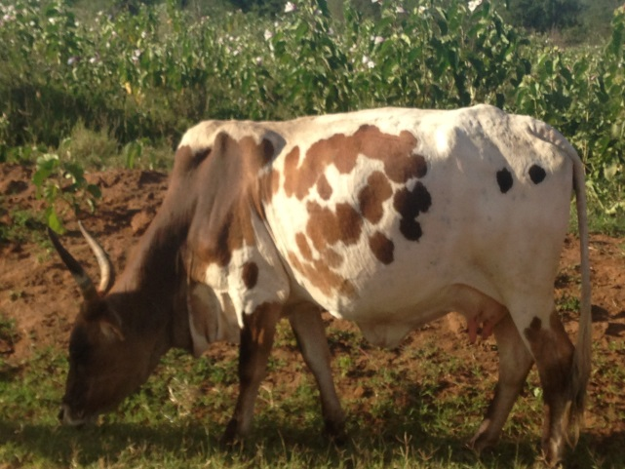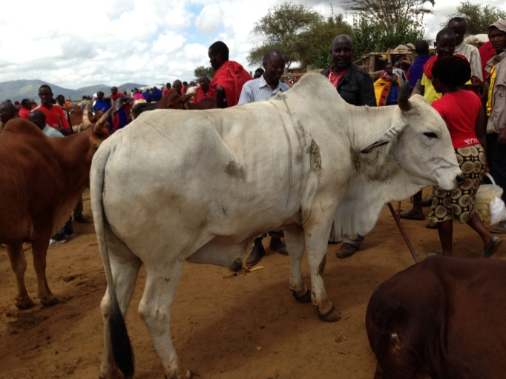
Traditional Maasai Zebu cow Traditional Maasai Zebu steer (7-10 years)

In order to foster livestock improvement in the SORALO area, the SORALO Cattleman’s Project was launched in 2008. With the financial support of the Dutch Embassy in Kenya, SORALO purchased several Sahiwal bulls as well as 30 Sahiwal heifers. Sahiwal cattle are a dual purpose Zebu breed originating from Pakistan and are known for their fast growing calves and high milk yields. By distributing several Sahiwal bulls across the landscape and making them available for breeding free of charge, this program has provided many community members with access to these genetics. The idea here is that the crossbreeding will result in larger, more productive and more valuable cattle that maintain some or all of the drought and disease resistance inherent to the smaller, hardier Maasai Zebu cattle. It is important to note here that the “native stock” of the Maasai has been adapted to this climate, forage, and terrain over millennia, and these changes in species by cross-breeding and altered genetics are more a response to market conditions and global influences than for improved resilience to such things as climate change and land allocation.

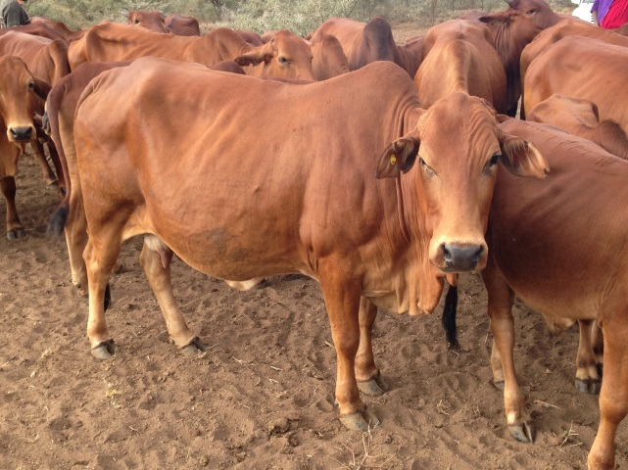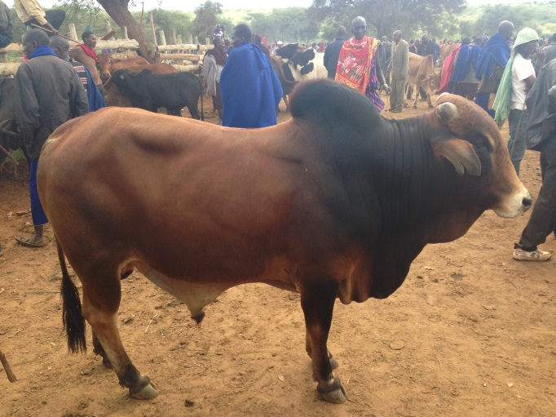
Exotic Sahiwal cow Crossbred bull (Maasai/Sahiwal) 3-5 years old

The initial results of this program are promising, with reports of several hundred crossbred animals making up a small but noticeable percentage of local herds. Currently the program remains self-sufficient through the selling of surplus animals to community members at discount prices. Beneficiaries of the program report increases in milk yields, higher prices paid for live cattle, and the potential for reducing the number of animals needed to meet their financial needs and the reductions in pasture and mobility due to land subdivision. The animals are currently (2015) kept in one location and the main challenge for the program is mostly centered around ensuring ongoing and widespread access to these animals for breeding to meet the growing demand for these services. The initial acceptance of this project by these communities and its initial success suggest that expanding the program has the potential for widespread benefits, not only in terms of increased milk yields and monetary returns for live cattle sales, but also as a means of reducing overall cattle numbers to match reductions in pasture due to land subdivision and new uses.

Cooperative Milk Marketing

Traditional Maasai culture determines that within the household milk belongs to the women who are responsible for milking the cows, and that after household needs are taken care of they may dispose of extra milk in any way they please. Many Maasai women have taken advantage of this to sell milk, but until recently outlets for selling their milk have been limited to local establishments, including hotels, etc. Cooperative marketing of livestock products is one way to help individuals and households, especially women, add value and access to markets by aggregating supply in designated locations. For example, Enaidurra Dairy Cooperative Society, in central Kajiado County is a self-help group that brings together several hundred Maasai women to sell milk in bulk to Brookside Dairy Limited, the largest dairy processor in Kenya. Each day during the rainy season and the productive months that follow women bring their milk to central locations where it is collected and transported to Brookside’s processing facility in Nairobi. Founded in 2012, the Group currently consists of approximately 700 members, mostly women, but also including several men who are paid in milk by the women to collect and transport their product from their homes to the more centralized locations for company pick-up.

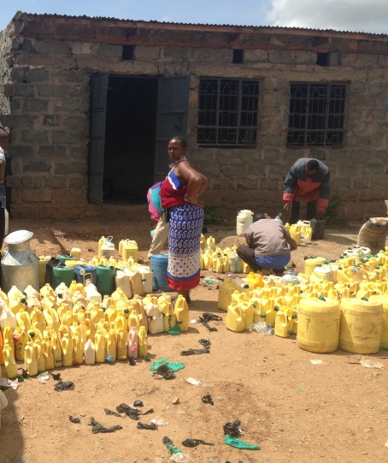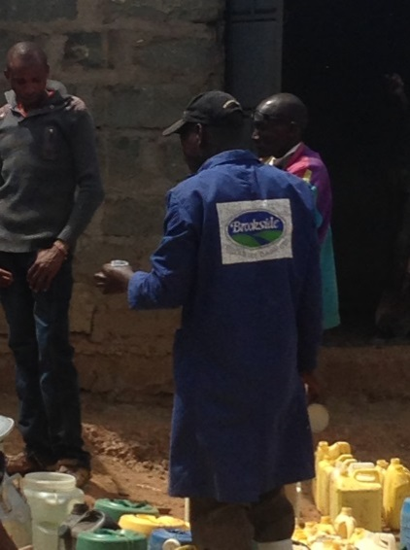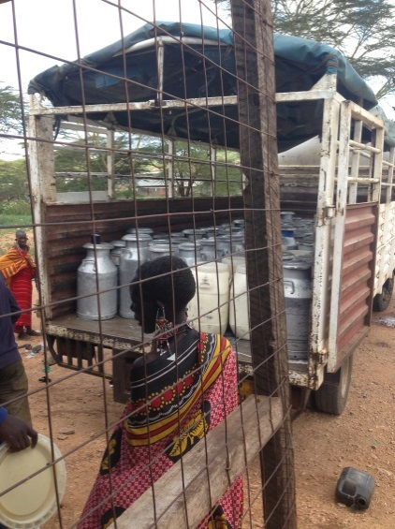
Maasai women selling milk to Brookside Dairy Limited in Bisil, Kenya in March 2014

Data collected for March 2014 indicates that Brookside paid 649 members a total of over 5 million Kenyan shillings for almost 160,000 liters of milk, an average of 242 liters sold by each member and almost 8,000 Kenyan shillings paid to each individual member for the month, many of whom get paid by direct deposit to newly created bank accounts. Projects like this are effective in part because they put money directly in the hands of women by taking advantage of the aforementioned Maasai traditions determining milk to be the property of women. Based on research interviews conducted over the last two years with several members of the group, members are primarily using this money to pay fees and buy uniforms for their children assisting them to attend school, as well as buy food and other household supplies. In some cases they are using the money to improve their family’s livestock by purchasing more productive animals. The Cooperative also collects a small fee from every liter of milk sold to support itself and employ a few staff members.

There are some indications that the additional income derived from selling milk in this manner may also be helping some households reduce the pressure to sell land and/or engage in environmentally destructive practices like harvesting scarce trees for sales to charcoal merchants. For example, one of the group’s members was able to borrow 100,000 shillings from the group to help cover the school fees for her children. She was then able to convince her husband not to sell a portion of their land to cover the children’s expenses, and will pay back the loan over time based on having a portion of her future milk proceeds being deducted each month. Although not a SORALO project, the Group gets financial and technical support from the Pastoralist Initiative for Development (PIDe), a community-based organization founded by the Chairman of SORALO who wanted to ensure that Maasai women could access and benefit from increased milk yields resulting from the crossbreeding of local Maasai cattle with the Sahiwal and other exotic breeds.

The potential to involve more women and more households in cooperative milk marketing is huge, considering Kenya’s growing urban population, the close proximity of the South Rift to Nairobi, and the fact that milk from Maasailand is sought after by both Brookside and other milk processors in Kenya including the new Kenya Cooperative Creameries Limited (KCC). This is due largely to its high fat content based on the diversity of vegetation consumed by cattle feeding mostly on native forage. One of the major challenges for the milk business is the need to find better ways for women to store and/or transport milk in a manner that maintains freshness, both at home and at the marketing level (see addendum 1). The other challenge is that although milk volumes are plentiful during the rainy seasons and the months that follow due to the abundance of grass and other vegetation available for grazing, milk volumes decline significantly during the dry seasons and become almost nonexistent during prolonged droughts. This shortage is exacerbated by the fact that many households must move their herds far from their bomas (homes) in search of available pasture, leaving the Maasai women who stay behind with no opportunity of obtaining and selling even what little milk may be being produced by the cows during these times.

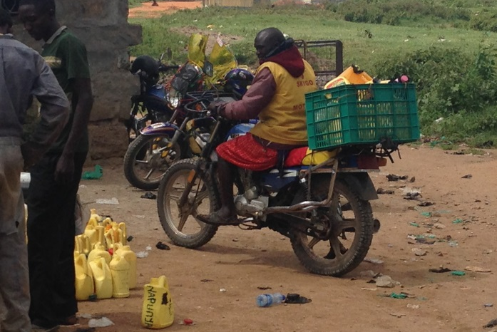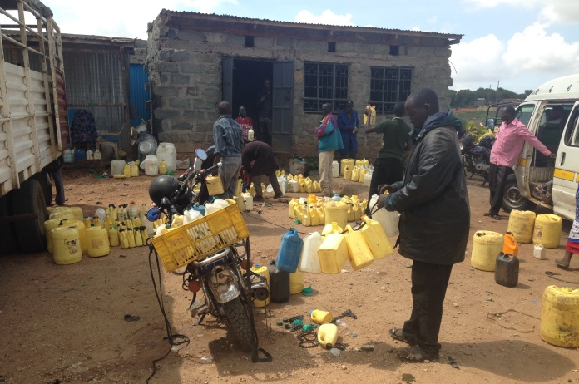
Maasai men hired by women to transport milk to collection point

At the group level, options for maintaining milk freshness could include the installation of chilling machines at collection points, but the high cost of this infrastructure makes it difficult
to obtain. Individually, replacing the usual variety of plastic containers with more hygienic and standardized types would potentially aid in maintaining milk freshness. One potential solution for maintaining some semblance of milk production during dry seasons and prolonged droughts, include acquiring land either through purchase or donations to be managed cooperatively in individual communities where grass can be reserved during rainy seasons. Individual women then can bring a few cows and their calves to graze during dry seasons and the animals could also potentially be given supplemental feed. The feasibility of this option is yet to be explored in detail and is potentially challenged by local preference to keep cows together and in the company of bulls year-round. SORALO, with its herd of pure Sahiwal could potentially provide bulls to be stationed at these milking camps, or moved from place to place, but again the feasibility of this option has not yet been explored. Identifying and assessing the feasibility of options for increasing the number of households benefitting from cooperative milk marketing as well as ensuring the year round production of milk is an important area that could benefit from SORALO’s leadership. Another additional option to explore is the increased and more wide-spread production of value-added milk products like cheese and yogurt, possibly even for export.

Marketing Live Animals

In terms of opportunities for marketing live animals, the South Rift is home to two established regional livestock markets: Bisil and Shompole, as well as several smaller and more informal markets. The Bisil market is located approximately 100 km south of Nairobi on the main highway that connects Nairobi with Arusha, Tanzania. Since 2012 when the Kajiado County Council helped expand the market to a larger, more permanent location, the Bisil market has grown from an informal market with a few hundred animals weekly to become one of the largest livestock markets in all of Kenya’s Maasailand. It is estimated that on a typical market day over 1,000 head of cattle and approximately 3,000 goats and sheep change hands, many of them several times throughout the day. Large numbers of the animals are destined for slaughterhouses and other markets in and around Nairobi, and livestock keepers from across the South Rift, and even as far away as Tanzania bring their animals to the market. With the ever-increasing use of mobile phones, marketing of all kinds is rapidly changing, and livestock transfers are no exception. Phones are now used for all kinds of banking transactions, for exchanging information about current prices of livestock at different markets, and for sending pictures of animals to prospective buyers who are not present in person at these sales.

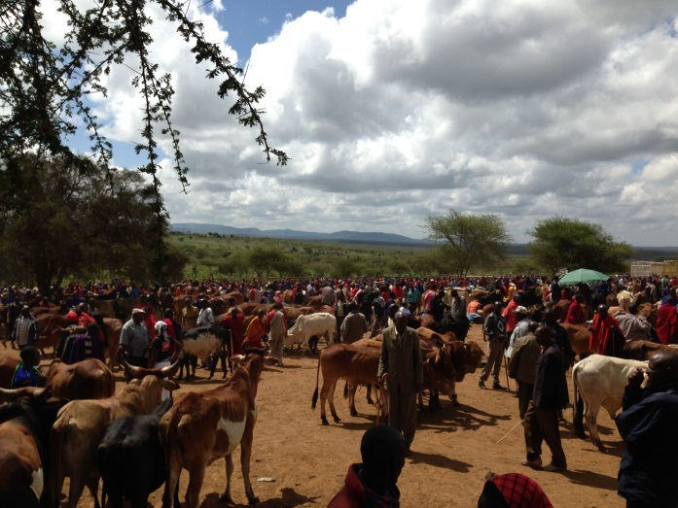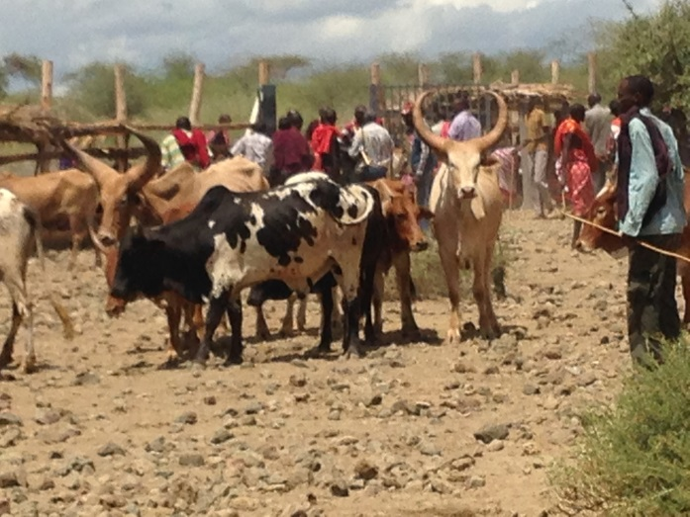
Livestock market in Bisil, Kenya Livestock market in Shompole, Kenya

In addition to providing a market for live animals, the communities in the surrounding area benefit directly from this market due to a small fee that is collected from each seller for each animal upon entering the market. After covering its expenses, Dupot-O-Losho, the local community-based organization that manages the market and collects the fees, donates all of the proceeds from the market in the form of bursaries or scholarships to help pay school fees for needy children. Since the market was expanded in 2012, the group has dispersed 4.3 million Kenyan shillings to pay school fees. The market in Shompole, although smaller than the one in Bisil, provides an outlet for livestock keepers from the intact group ranches near Magadi. With growing markets in Asia and the Middle East, that is another arena to explore for its potential to add significant value to sales of live animals. Encouraging individuals to purchase young animals in groups, fatten them, and resell them for profit is one way that SORALO might help more households benefit from the live cattle market, especially poorer families with fewer animals in their possession.

Meat and Other Products

Currently, with only one established slaughterhouse in the region (located next to the live sales market in Bisil) opportunities for individual livestock keepers to sell meat directly to butcheries and other consumers is limited. One option being discussed by SORALO is the potential to develop a slaughterhouse in Magadi where individuals or groups of individuals could bring their animals for slaughter in order to sell meat direct to consumers and businesses both locally and in Nairobi. In addition to selling meat, one of the advantages of being able to slaughter animals locally is to add value through the retention and selling of hides and other byproducts. Encouraging livestock producers to form cooperatives and finding investors to develop processing infrastructure is one more way that SORALO can help add value to livestock and associated products.

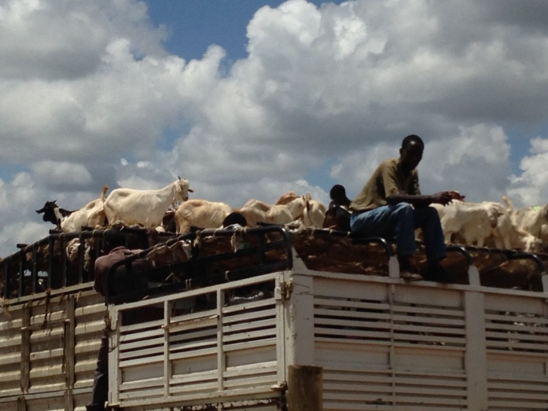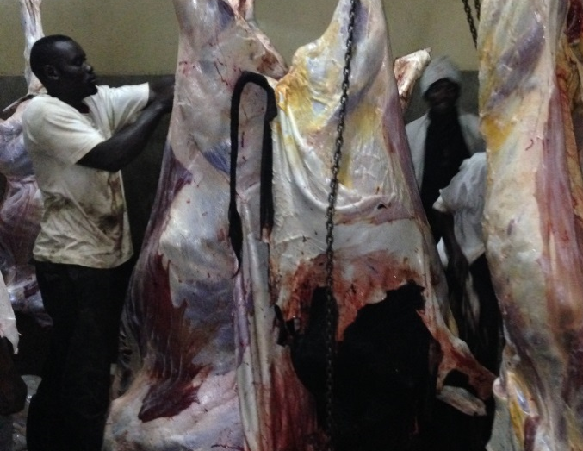
Transporting goats from the Bisil Market Inside the slaughterhouse at Bisil, Kenya

Land Use Planning

In order to ensure that there is enough open space for grazing and to maintain access to water for both human and livestock consumption, SORALO should work to promote land use planning and outreach targeted at individual landowners and at the community-level scale. Regarding the individual parcel level, landowners need to be made aware about land issues and their rights, and encouraged to consider aggregating their individual parcels with their neighbors to create larger pastures. This may allow them to be able to set aside certain areas as dry season grazing reserves for a diversity of animal species and age classes. In its most recent strategic plan SORALO proposes to address land use planning at larger scales. These include developing land use plans for each cluster of settlements within SORALO, assessing levels of range degradation in each, encouraging conservancies and grass banks, protecting water catchments, developing livestock management plans, influencing legal frameworks for land use planning at both the local and county government levels, and establishing formal land use associations among groups of landowners. Specific additional challenges and opportunities to consider could include controlling invasive plant species, mitigating human-wildlife conflict, minimizing environmental destruction due to charcoal and sand harvesting, and pasture improvement through reseeding.

Conclusion

These recommendations and ideas, solicited from community members themselves, offer an excellent opportunity for SORALO, favorably positioned as a trusted, community-based organization whose authority is given by the Maasai communities themselves, to be the foremost entity working directly with individual landowners and communities in the South Rift, and assisting in the development of positive solutions to the challenges they face as pastoralists and livestock producers. Taken together, expanding efforts to promote and facilitate livestock improvement, supporting existing and developing new cooperative arrangements and business partnerships for marketing of livestock and livestock products, and encouraging land use planning at the individual landowner and community scales have the potential to increase financial returns to individual households, incentivize open space conservation, reduce environmental destruction, and make livestock keepers more resilient to climate change over time. The reality of these climate changes confirms that all of these options are necessary both for the short-term and long-term resilience of the Maasai people, their livestock, the land, and the wildlife they share it with.
______________________________________________________________________________

ADDENDUM - based on the TEAM’s visit to Kenya to continue Shiloh’s work, February 2017

1. Facility and packaging improvements for milk production and marketing

At the time of the TEAM’s journey in early 2017, the Milk Cooperative had received and/or raised nearly enough funding to complete construction of a centrally located building for collection, cooling, and storage for shipment of their products. $3,000 remained to be raised for a cooler that would provide quick-chilling for the milk, for a sanitary cleaning station, and for toilet facilities. This money was raised by Shiloh’s family and friends within a month of returning home, and those additions have been completed.

Another innovation which is being pursued is the development of standard size and shaped containers for transport of the milk. These need to be reusable many times, shaped for efficient and uniform stacking arrangements on the small motorcycles utilized for their transport from their origin among the villages. Currently the variety of shapes and types of containers greatly reduce the number of these which can be efficiently moved to the central dispersal locations. The other need identified by the women of the milk cooperative is for large openings in the containers so they can be thoroughly cleaned and sanitized for keeping of the product fresh by preventing spoilage from any difficulties cleaning them each time they are used. The TEAM is hoping that the engineering aspect of our investigation can result in meeting these needs with design and production ideas and trials.

2. Re-cycling and re-using

The problem of trash and waste in the villages and towns of Maasiland occurs practically everywhere, where there are people living together without available waste disposal services or locations. Specifically, plastic bags and bottles constitute an apparently insurmountable and pervasive contribution to such things as pollution of waterways, and death among both domestic and wild animals who ingest such products, often for the remaining food garbage left in them, and then suffer indigestion and an inability to pass their own waste. The two factors that were identified as major impediments to reducing this element on the landscape were lack of collection operations and locations for disposal, such as landfills or dumps, and the absence of any use for such products with no infrastructure to re-cycle and process these materials, primarily plastic bottles, and other containers and wrappings, than by discarding them across the landscape and/or burning them.
(Late flash: Kenya has just passed the world’s strongest legislation banning plastic bags from the entire country).

There is interest at the community level for dealing with these problems. At one workshop, there were attendees who represented an effort to engage youth in both gathering and re-manufacturing of these waste streams. There are already certain operations as close as Nairobi engaged in their use as building products and other possibilities. SORALO and other groups could advance this effort to gather and re-use plastic waste, while creating employment and a healthier environment for people and for animals. Bringing committed and interested individuals or representatives of groups to Nairobi and the US, to discover and observe the potential for these activities, as well as utilizing engineering assets of the TEAM to further investigate these option, would be a useful step forward.

3. Predator-Livestock Conflicts and Possible Solutions

The TEAM was very interested in the use of what are called “Lion Lights” used around the corrals and night quarters of local livestock owners. Batteries, and strings of long-lasting, tiny bulbs can be used, especially for smaller stock such as sheep and goats which are usually brought home each night. The young inventor of some of these applications was able to develop randomness in their action that kept the predators from getting used to them and ignoring their original value as prevention successes. One drawback of this technology is the need to transport heavy vehicle batteries to charging stations in nearby towns. Solar panels would be one solution to this.

Another tool that has not seen much use is the electric fencing, so common in the western USA. Placed at strategic heights, charged wires can dissuade many predators from crossing their boundary. Again, solar charging can be used to accumulate and store power during the daylight hours for use during the night. The components for these “chargers” are quite simple and could be acquired and then assembled locally, thereby stimulating a small-scale spin-off business opportunity, and avoiding the need for moving large batteries to sometimes distant charging stations.

4. Improving water sources and storage

Walking or driving for water to be brought home for drinking, cooking, and cleaning is often and arduous and time-consuming chore. Moving cattle to available, but often distant sources, is also problematic. While it would usually be a cost-prohibitive venture to bring piped water to large areas, the presence of groundwater accessible by wells is available in many locations. The cost of digging and installing the well is very likely beyond the means of most land-holders and villagers, but the possibility of shared and cooperatively paid-for sources should be considered. The role of government in subsidizing the initial outlay of funds merits investigation. Maintaining the equipment and paying for the pumping of this water from below ground is another potentially expensive outlay. However, recent improvements in the efficiency of pumps themselves, and the use of solar power for their operation is an opportunity that is only now being taken advantage of in limited and far-flung areas. As in other previously mentioned applications the simplicity of solar panel assembly and the increasing availability of components suggests this is another potential for small local businesses and employment.

Another source of water, when the rainy season occurs, is from roofs and other run-off sources particularly in towns. The collection and storage of this resource can be a challenge, but in many cases this could be a one-time expense for tanks, cisterns, or plastic-lined underground storage ponds which can reduce evaporation The other limiting factor in the storage of collected water is its contamination, and/or purity. There are now many NGOS working on the African continent to solve this problem with small-scale and community-sized filtration devices which can serve this purpose.

5. Metallurgical research

One member of the TEAM is a Professor of Archeology specializing in the study of evolving metallurgical technology, primarily from pre-historical sources. A proposal has been submitted to PIDe seeking funding to investigate the earliest metallurgy and its subsequent development in Africa. One aspect of this undertaking would concentrate on documenting, resurrecting, and recovering traditional iron smelting sites of the Maasai tribe in Kenya for the first time ever, in order to compare products of this surviving technology with artifacts from other regions and eras of the world’s history.

As a secondary research objective, although the modern metallurgical industry is monitored in order to reduce heavy metal pollution, there has been very little research into the long-term pollution caused by ancient metal-working industries. This is an important question for modern populations, since ancient metallurgical workshops often operated for hundreds of years, leaving heavy metals in the soil and degrading the environment over long-periods of time, as these materials are likely to be non-degradable. The long-term impacts of this pollution on both ancient and modern populations, has never been studied comprehensively. This project aims to develop a methodological protocol that can be used to analyze and even remedy any polluted archeological site by analyzing changes in metal content from several excavated layers of the soils.

In addition, the TEAM and some of its hosts in Maasailand are very interested in conducting interviews with the few living practitioners and custodians of the knowledge of this technology, and producing documentation useful in the preservation of ancient and traditional sources, methods and the blacksmithing of metals among the Maasai. The project would address both the evolution of the technology, as well as its ecological impacts, providing an in-depth look at ancient industrial processes that has never before been attempted. Given the remoteness of many Maasai settlements, perhaps reviving certain aspects of these practices could also be accomplished for the benefit of communities.

6. Collaboration

Some of the important lessons learned and suggestions for next steps for our TEAM are those involving recommendations for ways and means of communicating in semi-formal contexts between two distinct social-cultural traditions and formats. Community-led decision-making group processes from America and Barazas from Maasailand have both similarities and differences in their methods and objectives. In the attempt to blend and or utilize elements of both there are pitfalls to be avoided as well as strengths to be encouraged. The Maasai have a very strong oral tradition that demonstrate strong group dynamics and the effectiveness of these in lengthy discussions where any and all participants are encouraged to make themselves heard. We found that, as Americans, we were often relying on visual presentations and communication, such as workbooks, flip-charts, power points, and other products, and these sometimes proved less satisfactory than our own spoken words with the Maasai.

The difficulties caused by language differences, and the timing and time involved necessary for having translators is another factor which requires some getting used to by both groups. A corollary of this issue is the need to have local community contacts and leaders to gather the participants and share in the responsibilities of discussion and the exchange of learning and ideas. It was also apparent that half-day sessions were more useful, and when held on consecutive days, would usually be better attended than anything of a longer timespan on one full day or multiple whole-day sessions.

Postscript

Shiloh’s research and his preparation of the initial version of this document have already had significant impact on the strategic planning and measurable success of SORALO and the communities it serves. These initiatives and our collaborative efforts will continue arising out of this inspiration, and will be developed for their application to helping people in both countries. Our TEAM’s journey to Kenya had as its primary purpose our desire to follow in his footsteps and to validate and carry on his work. These ideas and their potential are going to have a large impact both on the communities and people he met and loved in Maasailand, and on ourselves. The next steps and our joint planning for the future will be based on this Report and other aspects of his work, on our own increased understanding of the issues, and the new knowledge gained from using the Bridge that has been created between our two peoples. Our TEAM is truly grateful for the wonderful and heart-warming welcome and generous hospitality we received by engaging in this endeavor with our hosts and their communities, and from all of Shiloh’s friends in Kenya, who are now ours as well.

