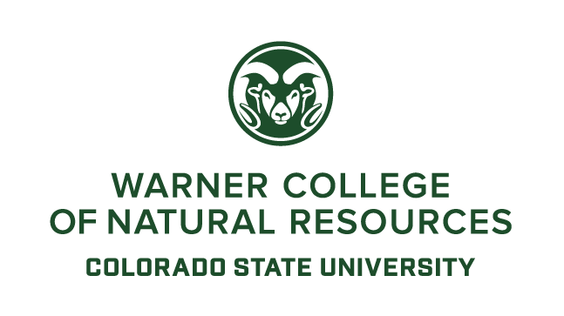
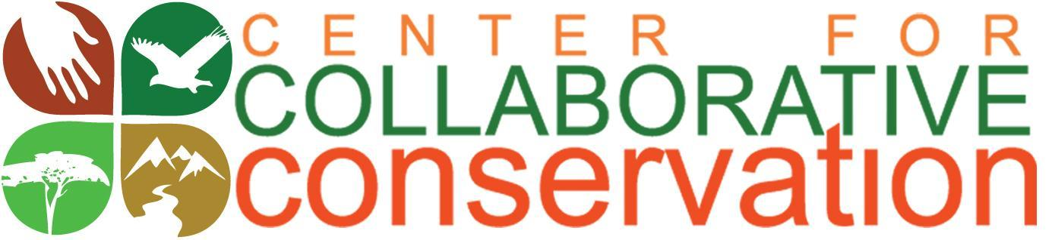

Collaborative Conservation Fellows Program
Request for Cohort 11 Proposals 2021-2022
Submission Deadline: November 2, 2020

The Center for Collaborative Conservation (CCC) at Colorado State University (CSU) invites both individual and team applications for its Collaborative Conservation Fellowship Program, Cohort 11.
We accept applications from:
- Practitioners: people who use, own, or manage natural resources as individuals (like landowners, ranchers, foresters, farmers) or who work professionally as part of tribal nations, the private sector, NGOs, government and state agencies and other entities
- CSU graduate students from all CSU colleges and departments
- CSU faculty, research scientists, post docs, and extension agents from all CSU colleges and departments

The CCC is strongly committed to the Diversity, Equity, and Inclusion (DEI) efforts of Warner College of Natural Resources. The Fellows Program seeks to increase the diversity and representation of our fellows to provide deeper cultural learning among the cohort, and increase collaborative research, education and practice opportunities for underserved communities. In addition, we recognize that COVID-19 has disproportionately affected people and communities of color and those with limited financial resources. As such, we encourage applications from individuals who identify as belonging to an underrepresented group, and projects that focus on underserved communities.

IMPORTANT! All potential applicants should contact Kim Skyelander at the CCC to discuss their project topics BEFORE applying. This will reduce duplication of efforts already being undertaken at CSU. Email: kim.skyelander@colostate.edu.
A. Introduction

The Center for Collaborative Conservation
The Center for Collaborative Conservation (CCC) was established in 2008 in the Warner College of Natural Resources at Colorado State University (www.collaborativeconservation.org). The CCC promotes working collaboratively with diverse stakeholders to address conservation issues on public, private and indigenous lands across Colorado, the western United States and the world. Collaboration can result in more enduring conservation outcomes by incorporating the power of the collective wisdom, diverse viewpoints, and resources of a community in decision-making when addressing local social, economic, and ecological concerns.
The Fellows Program
Since 2008, the Center for Collaborative Conservation’s Fellows Program has challenged and encouraged students, faculty and practitioners to work together to help local communities sustain their livelihoods and conserve their landscapes. Fellows work across disciplinary, landscape, cultural, and administrative boundaries to find innovative solutions to conservation issues through on-the-ground projects in the United States and around the world.
Fellows Program Goals
- Build the capacity of the fellows as conservation leaders, both professionally and personally, through mentoring, training, and experiential learning in collaborative conservation.
- Find innovative and more locally driven solutions to conservation problems by directly involving communities and practitioners in all aspects of the fellows’ projects, from conception to dissemination of project results.
- Build an action network among practitioners, students, and researchers so they can share collaborative experiences, skills, and research to improve the processes and outcomes of collaborative conservation efforts.
Program Benefits to the Fellows
Alumni tell us that:
- Their fellowship experiences have led to significant, sometimes transformative, impact on their collaborative conservation work and careers;
- They have received a range of other lasting professional benefits from their fellowship experience including development of confidence, leadership, credibility, and networks;
- Their projects lived on and continued evolving years beyond their fellowship, conferring various tangible and intangible impacts to a range of stakeholders (e.g. communities, partners) and structures (e.g. education, policies);
- The fellowship provided an experiential, interactive learning environment comprised of four specific components: funding, project experience, interactions with other fellows and CCC staff, and a supportive fellowship community.
B. Fellowship Topics
Fellowship projects for this cohort may be any conservation topic in any geographic location, such as wildlife, water, forestry, rangeland, fisheries, climate change, protected areas, urban conservation, agriculture and food systems, policy, development, marine environments, indigenous issues, zoonotic disease, etc.
We are seeking projects that use collaboration to address conservation and livelihood issues. These projects should engage communities and/or stakeholders through every step of the work - from project design to decision making about project direction to the development and sharing of learning.
We encourage projects that are led by individuals who identify as belonging to an underrepresented group and/or projects that focus on underserved communities.
C. Timeline and Application Materials
The deadline for applications is midnight MST, Monday November 2, 2020. No late applications will be accepted. Completed applications should be sent to Fellows@collaborativeconservation.org on or before that date.
Decisions on successful applicants will be announced November 16-17, 2020 and will be formally recognized at CSU through the CCC. This eleventh cohort will run for 18 months from January 1, 2021 to August 31, 2022.
**Details on the program and all application materials can be found on the CCC webpage at www.collaborativeconservation.org/fellows.
D. Description of Funding Opportunity
Applicants may apply for either an Individual Fellowship OR a Team Fellowship.

Individual Fellowships
Individual fellowships are awarded to CSU graduate students, CSU faculty/researchers, and conservation practitioners.
- Graduate Fellowships: CSU graduate students enrolled in any CSU department may apply. Awards are up to $7,500. Graduate students must be officially admitted and registered at CSU to apply, and must be enrolled as a graduate student through the spring of 2022. Graduate students are required to collaborate with at least two conservation practitioners outside of CSU on their projects, and explicitly refer to this collaboration in the application. *See #3 below for the definition of a practitioner.
- Faculty Fellowships: Current CSU faculty members, research scientists, post docs, and extension agents may apply to this category. Awards are up to $10,000. Faculty fellows are required to collaborate with at least two conservation practitioners outside of CSU on their projects, and explicitly refer to this collaboration in the application. *See #3 below for the definition of a practitioner.
- Practitioner Fellowships: Practitioners include people who use, own, or manage natural resources as individuals (like landowners, ranchers, foresters, farmers) or who work professionally as part of tribal nations, the private sector, NGOs, government agencies and other entities. Awards are up to $10,000, Practitioner fellows are required to collaborate with at least one person (student, faculty, or researcher) at CSU, and explicitly refer to this collaboration in the application.
Team Fellowships
Teams – a team can consist of a maximum of three fellows: Teams can be made up of any faculty members, researchers, post-docs, extension agents, graduate students, or practitioners, but there MUST be at least one practitioner and one individual affiliated with CSU as team fellows. Teams may also include up to 4 collaborators (but the collaborators are not considered fellows and are not subject to Fellowship Requirements; see Section E). Team awards are up to $18,000.

E. Fellowship Requirements
**NOTE: Fellows MUST attend the Orientation Meeting, Reception and Retreat and at least 75% of the trainings. Failure to do so without written approval will result in expulsion from the program, loss of funds, and individuals being disqualified from calling themselves CCC fellows.

1. Activities
These activities are designed to grow the overall collaborative conservation program at CSU and elsewhere, and enhance the engagement, teaching and learning of all fellows. The format of these activities may change due to pandemic circumstances to ensure the health and safety of all participants and remain in line with state/CDC and CSU restrictions/guidelines.
- Orientation Meeting, Reception and Retreat: Fellows are required to attend the Cohort 11 Fellows Orientation Meeting (early December) and Reception and Retreat (mid-February). These will be in-person or on-line, depending on the circumstances. During Orientation, fellows meet each other and learn about the fellowship logistics and requirements. The Reception gives fellows a chance to introduce their projects to peers and guests and interact with past fellows. The one-day Retreat following the Reception allows for networking, planning, and training around the field of collaborative conservation. Project collaborators are welcome and encouraged to attend these events.
- Cohort Trainings: Fellows will be required to attend 4 in-depth, half day or full day trainings during the 18-month fellowship. These will be in-person or on-line, depending on the circumstances. Training topics will be chosen by the fellows at the February Retreat from a comprehensive list of collaborative conservation skills and tools. Trainings will be hands-on, provide peer-to-peer learning, and give fellows time to apply the skills and tools to their specific projects. Faculty and collaborators will have the optional opportunity to engage as co-trainers and mentors during these trainings. Project collaborators are welcome and encouraged to attend these events.
Training topics might include:
- Conducting a Situation Assessment
- Collaborative Research and Fact Finding
- Building Partnerships
- Science Communications Skills
- Cross-Cultural Learning
- Lessons Learned from Collaborative Conservation
- Facilitation Strategies
- Participatory Monitoring and Evaluation
- Stakeholder Analysis
- Understanding Power Dynamics When Collaborating
- Evaluating Your Collaborative Project
- Listening and Building Trust

- Support the CCC: Engage with the CCC both during and after the term of the fellowship. Fellows are encouraged to attend and participate in CCC activities such as participating on future fellowship review panels, acting as trainers for current and future retreats or short courses, contributing to CCC blogs, attending CCC social / partnership / networking functions, and participating in CCC conferences, workshops and/or special events.
2. Deliverables
All Fellows are required to produce the following deliverables. NOTE: Acceptance of the award constitutes agreement to post final products and a collective summary of the cohort’s final Fellows’ Reports on our website.
The CCC will also be using your final Fellows’ Report data (NOT your actual project data – see below) for future journal articles, internal reports, and fund-raising. By accepting a CCC Fellowship, you will be giving us permission to use your final Fellows’ Report data for these purposes. The CCC will keep your identity and sensitive information confidential.
- Final Products
    - Individual Graduate Student and Faculty Fellows
- Turn in one academic product.
Examples of academic products are: conference presentations, publishable manuscripts, models, conference posters, thesis or dissertation chapters, etc.
    - Individual Practitioner Fellows
- Turn in one practical product.
Practical products are items from your project that communities want and/or can use. These might include training guides, handbooks, media products, policy briefs for policy makers, workshop agendas and notes, digital and non- digital maps, community reports, etc.
    - Teams
- Turn in one academic product and one practical product.
b) Final Project Report and Program Evaluations
- Final Project Report: Each individual fellow and each team must complete a standard project report. These reports help the CCC quantify the impact of the team project on conservation and livelihoods in the project area, and to the field of collaborative conservation as a whole. Report guidelines will be given to fellows at the start of the fellowship and several times throughout the fellowship.
Journal notes: As part of the final report, fellows will turn in quarterly journal notes throughout the fellowship. Journal notes must address the questions from the final report so when it comes time to write the Fellows Final Project Report, fellows are not struggling to remember what they did over the course of 18 months.
2) Fellows Program Evaluation: Each individual fellow and each team fellow is required to fill out a CCC program evaluation form to evaluate the Fellows Program as a whole and offer suggestions for improvement. These evaluations are used to improve the program.

We define collaboration as action on a particular problem where multiple individuals, or organizations, must work together to solve a problem that none can solve alone. We define conservation as an action that promotes the sustainability of linked natural and human communities and the resources they both depend upon. Livelihoods may address economics, well-being and health, gender issues, power structures, trust and relationship building, or behavior changes.

