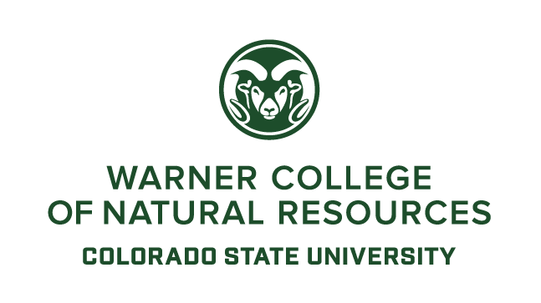
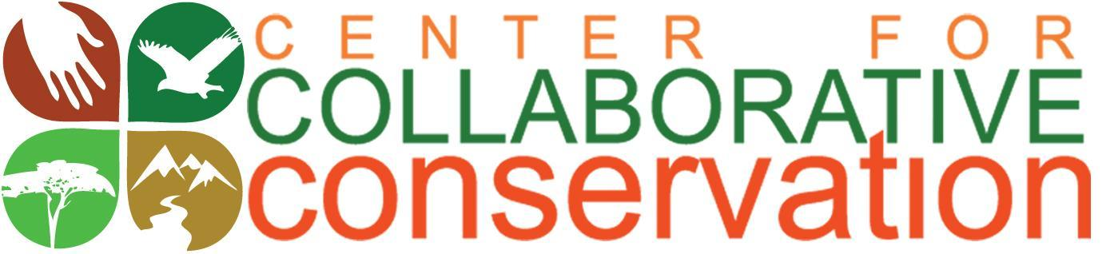

Collaborative Conservation Fellows Program
Request for Cohort 9 Proposals
2018-2020
Submission Deadline: November 2, 2017

The Center for Collaborative Conservation (CCC) at Colorado State University (CSU) invites team applications for its Collaborative Conservation Fellowship Program, Cohort 9.
IMPORTANT! All potential applicants should contact Kim Skyelander at the CCC to discuss their project topics BEFORE applying. This will reduce duplication of efforts already being undertaken at CSU. Email: kim.skyelander@colostate.edu.
A. Introduction

The Center for Collaborative Conservation
The Center for Collaborative Conservation (CCC) was established in 2008 in the Warner College of Natural Resources at Colorado State University (www.collaborativeconservation.org). The CCC promotes working collaboratively with diverse stakeholders to address conservation issues on public, private and indigenous lands across Colorado, the western United States and the world. Collaboration can result in more enduring conservation outcomes by incorporating the power of the collective wisdom, diverse viewpoints, and resources of a community in decision-making when addressing local social, economic, and ecological concerns.
The Fellows Program
Since 2008, the Center for Collaborative Conservation’s Fellows Program has challenged and encouraged students, faculty and practitioners to work together to help local communities sustain their livelihoods and conserve their landscapes. Fellows work across disciplinary, landscape, cultural, and administrative boundaries to find innovative solutions to conservation issues through on-the-ground projects in the United States and around the world.
Fellows Program Goals
- Build the capacity of the fellows as conservation leaders, both professionally and personally, through mentoring, training, and experiential learning in collaborative conservation.
- Find innovative and more locally driven solutions to conservation problems by directly involving communities and practitioners in all aspects of the fellows’ projects, from conception to dissemination of project results.
- Build an action network among practitioners, students, and researchers so they can share collaborative experiences, skills, and research to improve the processes and outcomes of collaborative conservation efforts.
B. Award
Team projects will receive up to $15,000, depending on the number and quality of applications. Final award amounts are at the discretion of the CCC. We encourage applications from practitioner organizations/agencies and all CSU colleges and departments.
C. Timeline and Application Materials
The deadline for applications is midnight MST, Wednesday November 1, 2017. No late applications will be accepted. Completed applications should be sent to Fellows@collaborativeconservation.org on or before that date.
Decisions on successful applicants will be announced on November 10, 2017 and will be formally recognized at CSU through the CCC. This ninth cohort will run for 24 months from January 15, 2018 to January 15, 2020. Details on the program appear below and on the CCC webpage at www.collaborativeconservation.org/fellows.
**Details on the program and all application materials can be found on the CCC webpage at www.collaborativeconservation.org/fellows.
D. Description of Funding Opportunity
Applicants may apply for a Team Fellowship.
Teams – a team can consist of a maximum of three fellows: Teams can be made up of any faculty members, researchers, post-docs, extension agents, graduate students, or practitioners, but there MUST be:
- at least one practitioner
- at least one individual affiliated with CSU and
- one CSU undergraduate student.
Teams may also include up to five collaborators or partner team members (but the collaborators are not considered fellows and are not subject to Fellowship Requirements; see Section F).

Definitions

- Graduate Students: Graduate students must be officially admitted and registered at CSU to apply, and must be enrolled as a graduate student through the spring of 2020.
- Faculty: Current CSU faculty members, research scientists, post docs, and extension agents qualify in this category.
- Practitioners: Practitioners include people who use, own, or manage natural resources as individuals (like landowners, ranchers, foresters, farmers) or who work professionally as part of tribal nations, the private sector, NGOs, government agencies and other entities.

- Undergraduate Student: The purpose of including these students is to give them an opportunity to study and practice collaborative conservation in an interdisciplinary team setting. Undergraduates may include their experience as part of a senior project, as a fulfillment of an internship requirement, or apply it as independent study credits toward their degree. This student can be chosen once the fellowship begins.

- Collaborators: collaborators are invited to participate in activities and can receive support from the fellowship (i.e., fellows may use CCC funds to support them in their project). Collaborators are not required to participate in activities nor are they responsible for final delivery of products. However, we welcome all team members to participate in all cohort activities if they have time and funding to support this.

NOTE: Past CCC Fellows may be a collaborator team member but may NOT be a team fellow.

E. Types of Projects

We are seeking projects that use collaboration to address conservation and livelihood issues. These projects should engage communities and/or stakeholders through every step of the work - from project design to decision making about project direction to the development and sharing of learning.

CCC may give preference to projects that address the following themes related to our strategic plan (although other topics areas are encouraged). Successful team projects will link both theoretical aspects of the following issues with practical examples / cases.

1) Markets for Ecosystem Services
• Identify the barriers and challenges to watershed investment funds or payments for ecosystem services around the world and how they are overcome.
• Identify practical models of using existing or new and innovative market-based tools for payments for ecosystem services.
• Explore when and how payments for ecosystem services improve community and ecosystem resilience.

2) The Phenomenon of Collaborative Conservation
• Explore and/or apply innovative approaches to documenting, measuring, or analyzing the direct or indirect outcomes and impacts of either individual collaborative initiatives or collaborative conservation efforts as a whole. (This may include community-based natural resource management, place-based conservation initiatives, and other relatives of collaborative conservation.)
• Research the conditions or factors that influence the effectiveness of collaborative conservation.
• Teams can propose to strengthen an existing conservation project by implementing or increasing the use of a collaborative approach, or can propose to start a new collaborative to address a critical conservation and livelihoods issue.
• Conduct a comparative study of the effectiveness of collaborative conservation approaches compared to more traditional conservation management, including an assessment of the cost of reaching ecological outcomes (environmental return on investment).

3) Collaboration Conservation Tools and Skills for Practitioners (practitioners include individual land owners and land users, non-profit employees, agency managers, business owners, and other people practicing conservation outside a university setting)

• Designing, implementing or providing training in collaborative tools and skills for current or future practitioners to increase the effectiveness of their collaborative practice. These may include People and Processing Skills such as:
- listening and communicating,
- interpersonal relationship management,
- facilitating and decision-making,
- understanding others interests,
- leadership,
- collaboration 101 - the need to understand the basics of the collaborative process including definitions, and how to form, manage and sustain collaborative efforts.

Projects may also include designing, implementing or providing training in Technical & Knowledge Tools such as finance and fundraising, legal, regulation & policy information, nonprofit & executive director training.

F. Team Fellowship Requirements

**NOTE: Team Fellows must attend ALL activities to receive funding.

1. Activities
These activities are designed to grow the overall collaborative conservation program at CSU and elsewhere, and enhance the engagement, teaching and learning of all fellows.

a) Reception and Retreat
Attend the Cohort 9 official Fellows Reception and Retreat (early March 2018- dates TBA). The reception welcomes the new fellows and you have a chance to introduce your project. The retreat is 2.5- 3 days of training in the skills and tools of collaborative conservation that you can use for your fellows project. Collaborators are welcome and encouraged to attend!

b) Cohort Meetings
Meet 3-4 times per year from April 2018 through October 2019 with other fellows and CCC staff to discuss your project as well as topical issues in collaborative conservation. Each team will be the leaders for a meeting and set the agenda (video conferencing will be available if not physically located near Fort Collins)
c) Mentorship
Assist other fellows as mentors and colleagues with the challenges they face.

d) Education
Contribute to short courses, classes, and/or trainings in collaborative conservation that are hosted by the CCC (dates TBD). May do so remotely.

e) Support the CCC
Continue engagement with the CCC beyond the term of the fellowship. Fellows will be welcome to attend CCC activities that occur after the fellow’s own cohort term ends. Such activities may include participating on future fellowship review panels, acting as trainers for future retreats or short courses, contributing to CCC blogs, attending CCC social / partnership / networking functions, participating in CCC conferences, workshops and/or special events.

2. Deliverables
All Teams are required to produce the following deliverables. If these items are not turned in, funding or reimbursements may be withheld until they are turned in.
Quarterly Products
- Blog posts: Each team is required to produce at least one blog post for the CCC website every three months on the progress, challenges, lessons learned and successes of their projects. Blogs must include high quality photos of the project.
- Journal notes: Turn in journal notes and high quality project photos every three months. Journals must address the questions from the final report so when it comes time to do the Fellows Final Report, all the notes will be in one place.

Final Products: These items can be turned in at the end of your fellowship in December 2019. However, the creation of these products should take place throughout your entire fellowship to ensure comprehensive reporting of your experience.
- Storytelling Video/Film: Tell the story of your fellowship project in a format that any audience can understand. Be creative. Show your field sites, do some interviews with community members or partners, but be sure to include the following requirements:
  - talk about the objectives of your project,
  - why the project is collaborative - and who you collaborated with and why,
  - any challenges and/or successes you have had,
  - lessons you have learned about collaboration while conducting the project, and
  - how your project is benefitting both people and the environment.
**Videos are due NO LATER than December 15, 2019. Do NOT wait until the end of the fellowship to get started. Start filming and story boarding from the beginning. CCC will provide some training on this.
- Research Product: at least one research product. Examples of research products are: conference presentations, publishable manuscripts, models, case studies, etc.
- Practical Products: At least two practical products that communities want and/or can use. These might include training guides, handbooks, films documenting lessons learned from a collaborative, policy briefs for policy makers, workshop agendas and notes, digital and non- digital maps, community reports, etc.

- Undergraduate Product: Undergraduate students are required to submit a written report to the CCC about their fellowship experiences and what they are learning. Other products such as video documentation of their project role are welcome as well, but not required.
These products will be shared on the CCC’s website.
Final Project Report and Program Evaluations
- Final Project Report: Each team must complete a standard project report. These reports help the CCC quantify the impact of the team project on conservation and livelihoods in the project area, and to the field of collaborative conservation as a whole. Report guidelines will be given to fellows at the start of the fellowship and several times throughout the fellowship.
2) Fellows Program Evaluation: Each individual team fellow is required to fill out a CCC program evaluation form to evaluate the Fellows Program as a whole and offer suggestions for improvement. These evaluations are used to improve the program.

We define collaboration as action on a particular problem where multiple individuals, or organizations, must work together to solve a problem that none can solve alone. We define conservation as an action that promotes the sustainability of linked natural and human communities and the resources they both depend upon. Livelihoods may address economics, well-being and health, gender issues, power structures, trust and relationship building, or behavior changes.

